Name : Dylan Goliat

NIM : 2602090063

Class : LC01

Major : Computer Science

SPACETD Project Documentatio

SpaceTD is a private Indonesian aerospace manufacturer and space transportation services company founded in 2002. The company's mission is to reduce space transportation costs and enable the colonization of Mars. SpaceTD designs, manufactures, and launches advanced rockets and spacecraft, with the goal of creating reusable launch vehicles that can be used for multiple missions.

SpaceTD is currently planning to create a website for their service, so they can reach more people from all around the world. First, SpaceTD needs to create a **website prototype** and company website that represents the SpaceTD image. With this website, SpaceTD hopes to improve service to its customers. SpaceTD entrusts you as a web designer to design their website prototype and create a company website.

The website consists of **five main pages**. They are **Home Page**, **Vehicles Page**, **Register Page**, **Programs Page**, and **Launches Page**.

The **requirements** from SpaceTD are described below:

1. SpaceTD wants you to design the **website prototype** of all **five pages** before making the HTML files. The website prototype will be created using **Figma**. Ensure the website prototype that you created is the **exact same** as the website that you will make later. Each page will contain **header**, **navigation**, **content**, and **footer** as its structure. Consider the **color**, **layout**, and **consistency** when designing the prototype.
2. SpaceTD wants you to build the **website attractive**, **appealing**, **fully functional**, and make sure the website is **responsive**. The website should be accessible using a mobile phone in a perfect way. To achieve that, use **5 kinds of CSS property** and **JavaScript**. Use **meta viewport tag** and **media screen rule** that will be applied if the screen is **below 768px screen width**.
3. The website consists of **five main pages**. They are **Home Page**, **Vehicles Page**, **Register Page**, **Programs Page**, and **Launches Page**. Below are the requirements for each page:
   * **Home Page**

This page shows SpaceTD’s **rocket launch video**, SpaceTD in numbers including **number of successful launches**, **landings**, **and reflights**. This page also shows SpaceTD’s **vision**.

* + **Vehicles Page**

This page shows all **list of SpaceTD’s space transportation**. Make sure to provide the **name, overview** (such as height, diameter, weight, etc.), and **image** **of the transportation** so people can get better insight about the transportation.

* + **Register Page**

This page provides a register form for the people who want to travel to space. SpaceTD needs a person’s **personal information**, such as **full name**, **gender**, **email**, **date of birth**, **password**, and **country**. You are asked to create **five kinds of form components** and **five kinds of validation**. For validation, you must create it using **JavaScript** and **don’t use regular expression**.

* + **Programs Page**

This page shows **all SpaceTD’s space travel programs**. Make sure to provide **name**, **description**, **flight** **duration**, and **image**.

* + **Launches Page**

This page shows **recent SpaceTD’s space mission**. Make sure to provide **launch date**, **mission** **name**, and **rocket launch image**.

Home Page

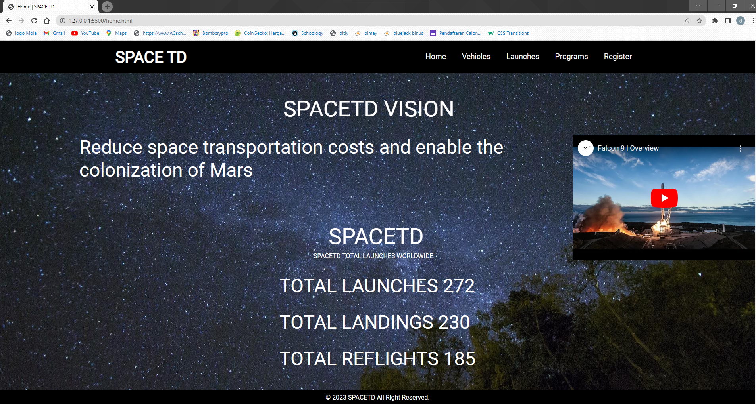

Vehicles Page

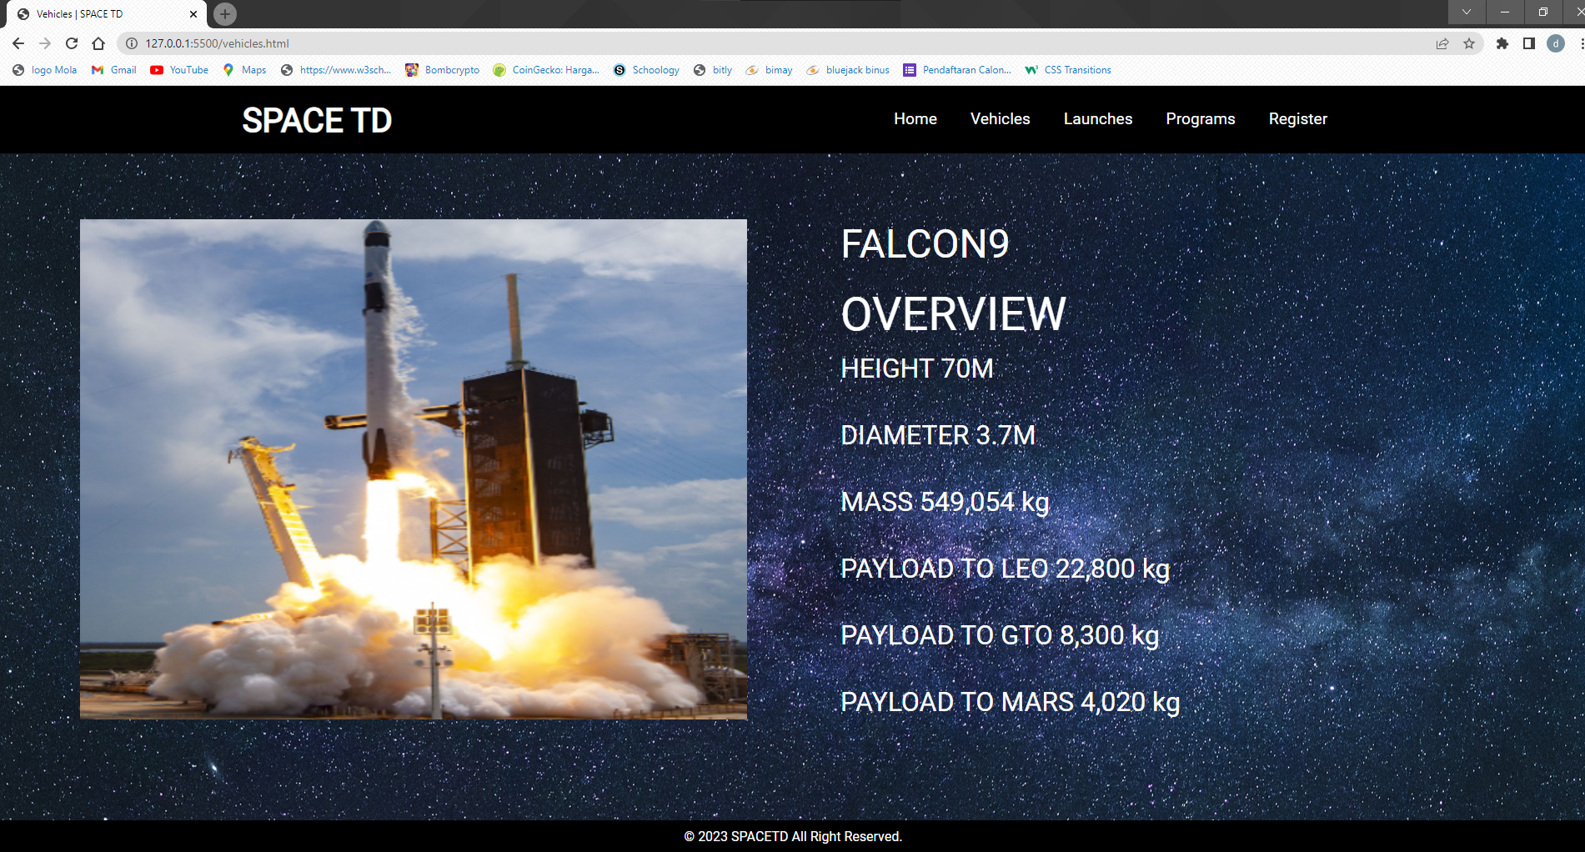

Launches Page

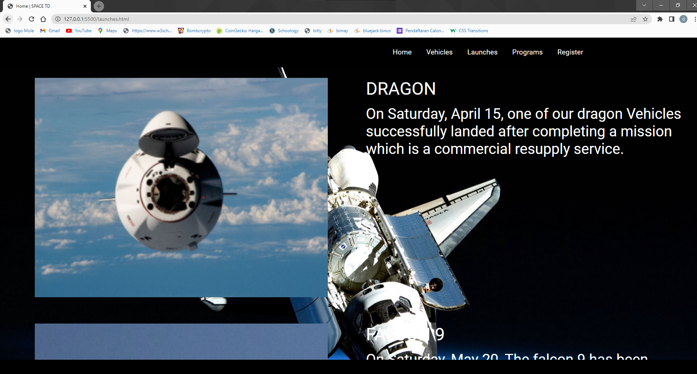

Programs Page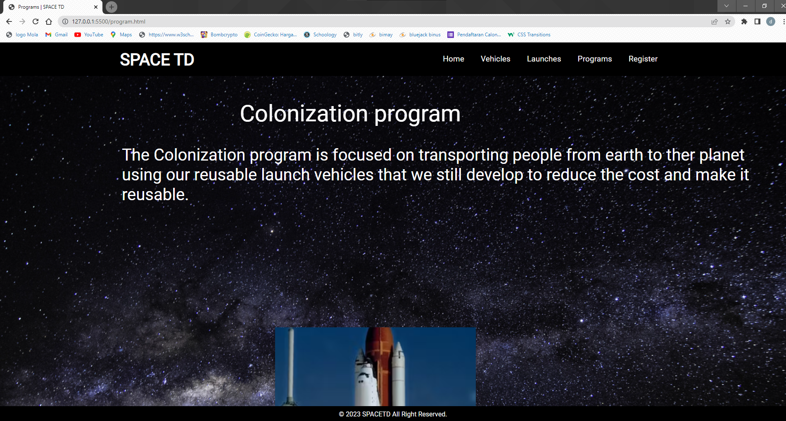

Register Page

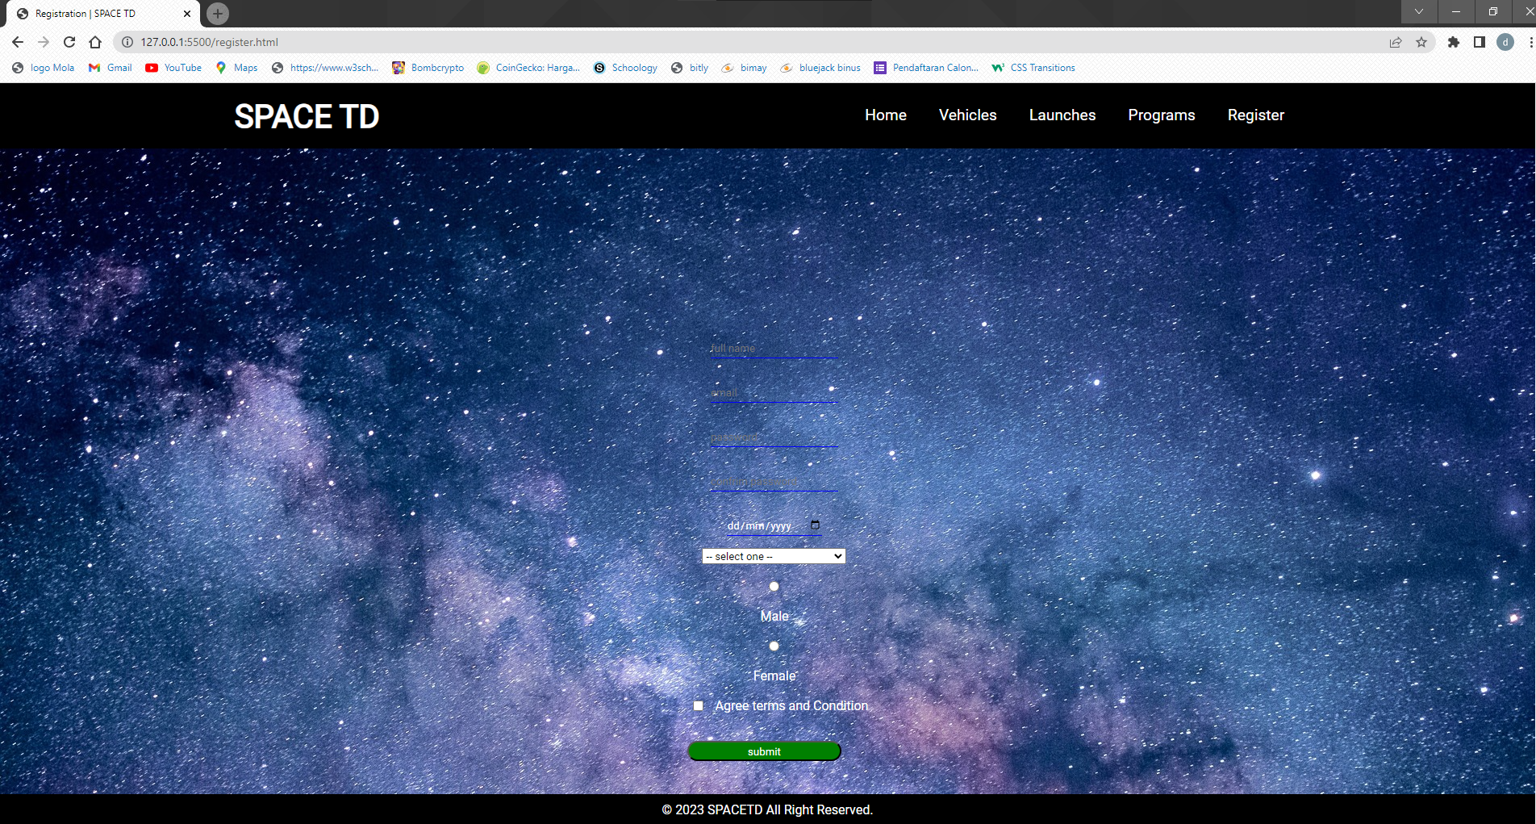

Link:

<https://www.figma.com/file/eqx5l9NXFykbRa8Jhz0Lai/Untitled?type=design&node-id=0%3A1&t=jqzEP4Zy500fDdq0-1>

<https://youtu.be/Z4TXCZG_NEY>

<https://pixabay.com/photos/astronomy-bright-constellation-dark-1867616/>

<https://pixabay.com/photos/milky-way-stars-night-sky-2695569/>

<https://pixabay.com/photos/milky-way-starry-sky-night-sky-2881461/>

<https://coolwallpapers.me/2860261-space-space-shuttle.html>

<https://coolwallpapers.me/5054447-space-space-shuttle.html>

<https://coolwallpapers.me/2859202-space-space-art.html>

<https://wallup.net/space-stars-41/>

<https://wallup.net/earth-universe-space/>

<https://www.goodfon.ru/download/kosmos-zvezdy-mlechnyy-put-3858/1920x1080/>

* Home Page

In this page there are Space TD data’s and an overview launch video, also this page shows the vision of Space TD

* Vehicles Page

This page shows list of vehicles that Space TD has for their missions and programs.

There are also data about the vehicles such as weight, diameter, etc.

* Launch Page

This page shows the recent launches that we do including the data such as image, date, name of vehicle, etc.

* Programs page

This page shows the list of programs that we provide for people who are interested about space or traveling.

* Register Page

This page provides a registration form for people who are interested or who want to take part in our adventure. This form requires full name , date of birth, email, password, country and gender.